Steering Group use
Consultee No.
Representation No.

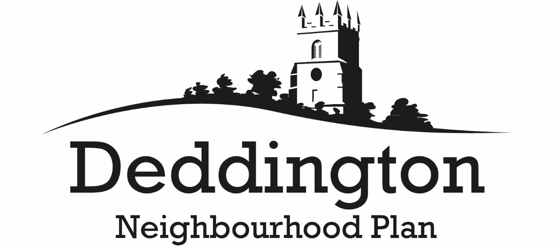

Pre-submission Regulation 14 Consultation
1 October to 19 November 2017
ALL RESPONSES MUST BE RECEIVED BY 19 NOVEMBER 2017

Representation Form

Please complete and return one form, or use a continuation sheet or sheets, for every representation made

Full name
Organisation
Address
Post Code
Email
Date

Please state to which part of the draft Neighbourhood Plan your representation relates
Page number
Policy number
Other

Please use the box below for comments

Thank-you for your comments. Please return this form by email to comment@deddingtonneighbourhoodplan.org or by post to Deddington Neighbourhood Planning Team, c/o Karmilla, Hempton Road, Deddington, OX15 0QG.

