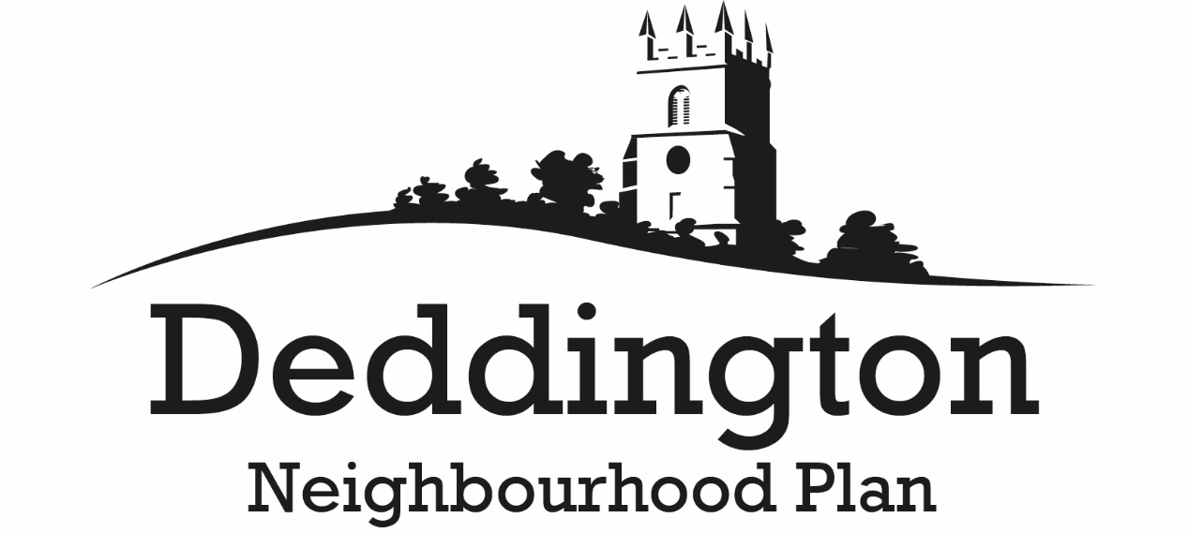

27 September 2017

Dear consultee/stakeholder,
Pre-submission Regulation 14 Consultation: 1 October to 19 November 2017
The emerging Deddington Neighbourhood Plan has now reached the pre-submission stage when residents and stakeholders have the opportunity to comment on the draft Plan and suggest possible improvements pursuant to Regulation 14 of the Neighbourhood Planning (General) Regulations 2012.
The comments received will be taken into account in determining whether any changes should be made to the draft Neighbourhood Plan. The revised Plan will then be forwarded to Cherwell District Council, who will conduct a statutory consultation in accordance with Regulation 16 before submitting the document to an independent examiner to check that it conforms with statutory requirements. If approved by the examiner, the Neighbourhood Plan, subject to any changes he proposes, will be submitted to a parish referendum.
The pre-submission Plan documents comprise the:
- Neighbourhood Plan;
- Consultation Statement; and
- Basic Conditions Statement.
The above three documents can be viewed online at, or downloaded from, the Deddington Neighbourhood Plan website:
http://www.deddingtonneighbourhoodplan.org/
'Hard' copies will be available for inspection at:
- Deddington Library, The Old Court House, Horse Fair, Deddington, OX15 0SH;
- Deddington Parish Council, Clerk's Office, Windmill Centre, Hempton Road, Deddington, OX15 0QH;
- Cherwell District Council offices, Bodicote House, White Post Road, Bodicote, Banbury, OX15 4AA.
You may respond:
- by making your comments on a representation form which you can download from http://www.deddingtonneighbourhoodplan.org/ and return by post or as an email attachment;
- by email to comment@deddingtonneighbourhoodplan.org
- by letter to Deddington Neighbourhood Planning Team, c/o Karmilla, Hempton Road, Deddington, OX15 0QG.
The consultation period begins on 1 October and ends on 19 November 2017.
When responding, please ensure that you have included your contact details. All comments will be publicly available and attributable by name and (where applicable) organisation. Postal and email addresses not in the public domain will be kept confidential.
Yours sincerely,
Alan Collins
Chair, Deddington Neighbourhood Plan steering group

